**K/1st Global Project Menu**

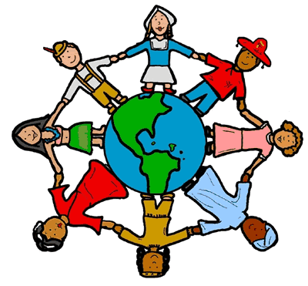

|  |  |  |  |
| --- | --- | --- | --- |
| **When I grow up, I want to be…** | | | |
| **An artist:** Make an art project from another country and write a sentence about why it’s important.  (Ex: colorful baskets- Zambia, piñata-Mexico, mosaic, masks-various) | **A diplomat:** Make a flag from another country. Write a sentence (or more!) about the flag. Write another sentence (or more!) about what a diplomat does. | **A teacher:** Read a book that is about or takes place in another country and show what the book was about in a diorama, picture, or short report. | **A dancer:** Learn about and perform a dance, from another country. Videotape it or do it for your class! |
| **A mapmaker:** Make a map of a city, country, or continent and label it. The map can be flat or 3-D. | **A researcher:** Make a poster showing what you learn about another country. | **An investigator:** Compare your lifestyle in the United States to the lifestyle of another country. | **A singer:** Sing or play a song from another country. Record it or perform it for your class! |
| **A zoologist:** Create a model of a South American animal. Write facts about the animal you chose. | **A musician:** Make a musical instrument and write a sentence about it and/or use it to play a song  (ex: maracas, Brazilian flute) | **A reporter:** Talk to someone in your family who has traveled to another country. Draw/make a collage and write about what you learn. | **A chef:** Make a menu of words or pictures showing foods from another country. Write about how the food is alike/ different that what you eat. |
| **A fashion designer:** Make part/all of the clothing of another country/culture. Draw it or model it, and then write a sentence about it.  (Ex: Carnival costumes, Egyptian jewelry) | **A scientist:** Make a diorama of a South American animal living in its habitat.  **C:\Documents and Settings\eblair\Local Settings\Temporary Internet Files\Content.IE5\XKQKRV3E\MC900192311[1].wmf** | **A detective:** Find out about a country that your family came from. Draw a map or make a collage and write a couple sentences about what you learned! | **An athlete:** Learn a game from another country. Draw a picture and write a sentence or more about the game. |